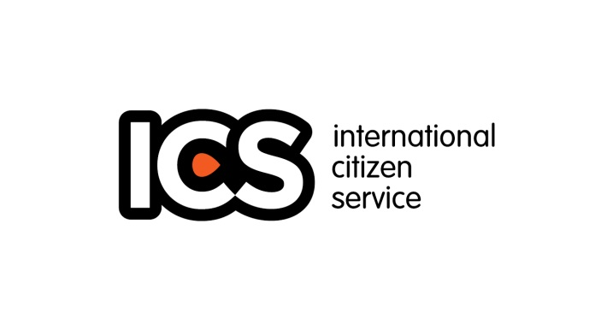

**VSO Community Youth Volunteer Application Form Nigeria**

**Completed forms should be returned to the VSO-ICS** **Team at**

**9B, Sangha Street, Off Mississippi Crescent, Maitama - Abuja**

**Or by email**

**icsprogramnigeria@gmail.com**

**The deadline for submission is 7pm 17th January, 2016**

**International Citizens Service (ICS):** This application is open to young Nigerians within the ages of **18 – 25** willing to volunteer alongside other young people from the UK in the community for 3 months (February – April, 2016).

**Volunteers must be sure that the information provided below is accurate. They should be willing to live outside their homes for 3 months and can cope with the required standards of behaviour before they apply for the programme.**

**Personal Details**

Title: Mr, Mrs, Miss., Dr, (Circle as appropriate)

First Name:

Surname:

State of Origin:

Current Address:

Nearest Capital City:

Marital Status: Sex:

Date of Birth:

Email Address, (active)

Mobile Number:

Contact Form: Telephone Email

(**How would you prefer we contact you)?**

**Background Details**

1. **Please state why you think you should be selected to be on any of the VSO youth volunteer programme?**

No qualifications, skills or experience are required to participate. We are interested in any motivations, circumstances, or interests that might make you a good candidate.

1. **Have you volunteered before? If so please give brief details.**

Yes in Nigeria at (Mention the organisation)  
Yes overseas with (Mention the Organisation) No

**\*Describe what the concept of volunteering means to you**

1. **Which aspects of youth volunteering will you find most challenging and why?**

From the list below, please tick up to three answers which best expresses what you foresee to be the most challenging aspects about going on the programme. You are asked to also provide an answer to the question in your own words in the field provided.

Being away from home Working in groups with others

Working in my community when returning Being in an unfamiliar culture

Being able to lead or share skills with others Doing the project / work placement

Surviving without the comforts of home Having skills that will be beneficial

Staying in a Host Home Other

**\*Describe your answer in your own words** (no word limit but it’s a requirement)

***Submit Application with the following Declaration***

By completing this form, I agree that VSO through the youth volunteering Programme will store and process my data in accordance with the requirements of their own Data Protection Policies and their Confidential Policies. They may pass my information to the relevant partner organizations in Nigeria and in-country staff, but will ensure that their counterparts continue to handle my personal information in accordance with their confidential and Data protection policies. They will hold any information I give them in order to contact me about my volunteering options. That they would also like to keep me informed about the range of ways I can become involved with the International Citizens Service.

Name:

**(typing your name here indicates you have agreed to the above statement)**

Date:

**N/B: All Completed forms should be returned to the VSO-ICS Team at 9B Sangha Street, Off Mississippi Crescent, Maitama - Abuja**

**Or by email**

**icsprogramnigeria@gmail.com**

Regards