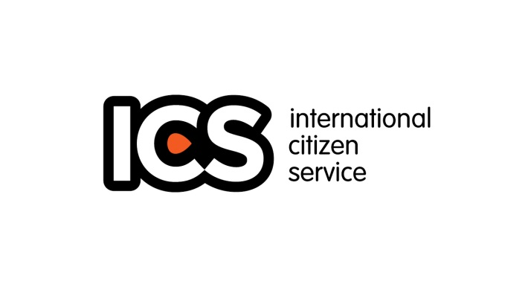

**VSO Community Youth Volunteer Application Form Nigeria**

**Completed forms should be returned to the VSO-ICS** **Team at**

**9B, Sangha Street, Off Mississippi Crescent, Maitama - Abuja**

**Or by email**

**icsprogramnigeria@gmail.com**

**The deadline for submission is 5pm 29th April, 2016**

**Community Citizens Volunteer (CCV):** Young people recruited to volunteer within the community they live in.

**National Graduate Volunteer Programme (NGVP):** Designed for you Nigerians who have completed their NYSC and last for a duration of one year in most cases

**NYSC – VSO Volunteer Programme:** Open to youth corps members willing to volunteer with VSO during their service year

**International Citizens Service (ICS):** Open to young Nigerians with the ages of 18 – 25 willing to volunteer alongside other young people form the UK in the community for 3 months

**Volunteers must be sure that they can cope with the above standards of behaviour before they apply for the programme.**

**Personal Details**

Title: Mr, Mrs, Miss., Dr, (Circle as appropriate)

First Name:

Surname:

State of Origin:

Current Address:

Home Address:

Marital Status: Sex:

Date of Birth:

Email Address, (active)

Mobile Number:

Contact Form: Telephone Email

(**How would you prefer we contact you)?**

**Background Details**

1. **How did you hear about VSO?**

VSO Staff

Volunteer

Ex-Volunteer

Others (please specify)

1. **If VSO Staff or Ex-volunteer, list names**

**1c. Which of the Youth Volunteer Model did you hear about?**

CCV

NGVP

NYSC

ICS

1. **How long are you available to volunteer For VSO?**

3 months only  
6 months only

1 year

Any timeframe

1. **Have you ever stayed with people who are not your relatives?**

Yes No

1. **When you return, are you committed to undertaking action to share your experience with others in your local community or wider society?**

Yes No

1. **What is your highest level of education?**
2. **What are you currently doing? (**Please tick all that apply)

Studying full-time Studying part-time

Working full-time Working part-time

Volunteering Training

National Youth Service Corps (NYSC) Year out / gap year

Studying on government training programme Unemployed

Other (please describe)

1. **Why would you like to volunteer for VSO Nigeria as a youth volunteer?**

From the list below, please tick up to three answers that best express why you want to go on the programme. You must also provide an answer to the question in your own words in the field provided.

Personal growth Interest in other cultures

Interest in international development Travel

Desire to understand more about poverty Practice my language skills

Gain new skills/experience Meet new people

Other

**\*Describe your answer in your own words** (no word limit but it’s a requirement)

1. **Which aspects of youth volunteering will you find most challenging and why?**

From the list below, please tick up to three answers which best express what you foresee to be the most challenging aspects about going on the programme. You are asked to also provide an answer to the question in your own words in the field provided.

Being away from home Working in groups with others

Working in my community when returning Being in an unfamiliar culture

Being able to lead or share skills with others Doing the project / work placement

Surviving without the comforts of home Having skills that will be beneficial

Staying in a Host Home Other

**\*Describe your answer in your own words** (no word limit but it’s a requirement)

1. **Please state why you think you should be selected to be on any of the VSO youth volunteer programme?**

No qualifications, skills or experience are required to participate. We are interested in any motivations, circumstances, or interests that might make you a good candidate.

1. **Have you volunteered before? If so please give brief details.**

Yes in Nigeria at (Mention the organisation)  
Yes overseas with (Mention the Organisation)  
 No

**\*Describe what the concept of volunteering means to you**

1. **What are your areas of interest?**

Education Secure Livelihood Participation and governance

\***in order of preference** **describe your interest and involvement in any or all of the above areas**

1. **What languages other than your mother tongue can you speak (at a basic conversational level)?**

Having a language is not essential to be on the programme but helps us understand your language skills.

**Additional Personal Information**

In order to ensure the youth volunteer programme is inclusive of all individuals within society and that we take on the required duty of care for participants, we need to collect some additional personal information. This information will be kept confidential and will only be used for reporting and planning purposes. It will not be linked to the selection criteria for your chosen programme.

**1. What is your ethnic origin?**

**2. Religion?**

**3. Do you consider yourself to have a major illness or disability?** (A disabled person is someone with a physical or mental impairment which has a substantial and long term adverse effect on the ability to carry out normal day-to-day activities)

Yes No

* If yes, describe the illness or disability (This is not a pre-requisite for selection, its only to help understand your medical condition so as to assist in time of need)

**Medical Information**

In case you are accepted to be on the programme, you need to complete a medical history form below in order to be medically cleared. This is to ensure that any medical condition you may have can be managed on the programme and that we can provide the appropriate support for you. The information you provide below will enable us to begin this process. All data will be treated as confidential. In some cases, a Medical Advisor may wish to contact your doctor to get details. If this is the case, you will be contacted to seek your permission to do so. Your doctor will not be contacted without your permission.

**If you answer 'yes' to any of the following questions, please give details:**

**1. Have you ever had any major illness, operations or accidents?**  
Yes No

* Give details:

**2. Have you ever suffered from any mental / physical health problems?**  
Yes No

* Give details:

**3. Are you taking any type of medication, or have you taken any medication in the last two years?**  
Yes No

* Give details:

**4. Do you have any objections or allergic reactions to specific vaccinations or medication?**  
Yes No

* Give details:

**Police Record**

1. **Have you ever been convicted for any criminal offence?**

No Yes (If yes, give an account of what happened)

1. **Are you currently implicated in any case under investigation or being prosecuted in any case (Criminal or civil)?**

No Yes (if yes, give details of the case)

**Referees**

As a part of the selection process we need to speak to two referees, which we ask you to nominate below. The first referee, where possible, should be someone who knows you in a professional capacity ie. is a tutor / teacher / co-worker / religious or community group leader / manager, volunteer supervisor or Youth NGO or any other NGO leader. The second should be someone who has known you well for at least two years but with a traceable address.

**First Referee:**

First Name: Surname:

Relationships:

Address:

Mobile Telephone: Email Address:

**Second Referee:**

First Name: Surname:

Relationship:

Address:

Mobile Telephone: Email Address:

**Emergency**

VSO should contact the following people should be contacted in case of an emergency while on ICS programme.

**First Emergency Contact:**

First Name Surname:

Relationship

Address

Mobile Telephone: Email Address:

**Second Emergency Contact:**

First Name Surname:

Relationship

Address

Mobile Telephone: Email Address:

***Submit Application with the following Declaration***

By completing this form, I agree that VSO through the youth volunteering Programme will store and process my data in accordance with the requirements of their own Data Protection Policies and their Confidential Policies. They may pass my information to the relevant partner organizations in Nigeria and in-country staff, but will ensure that their counterparts continue to handle my personal information in accordance with their confidential and Data protection policies. They will hold any information I give them in order to contact me about my volunteering options. That they would also like to keep me informed about the range of ways I can become involved with the International Citizen Service.

Name: Signature:

Date:

**N/B: All Completed forms should be returned to the VSO-ICS Team at 9B Sangha Street, Off Mississippi Crescent, Maitama - Abuja**

**Or by email**

**icsprogramnigeria@gmail.com**

**PLEASE MOVE ON TO THE NEXT PAGE**

**Additional Information**

Whether or not you are involved in the ICS team, you still have the opportunity to pass through the door of being an active citizen and being part of ICS community service

Let’s introduce you to “THE DOOR” and show you the journey to active citizenship.

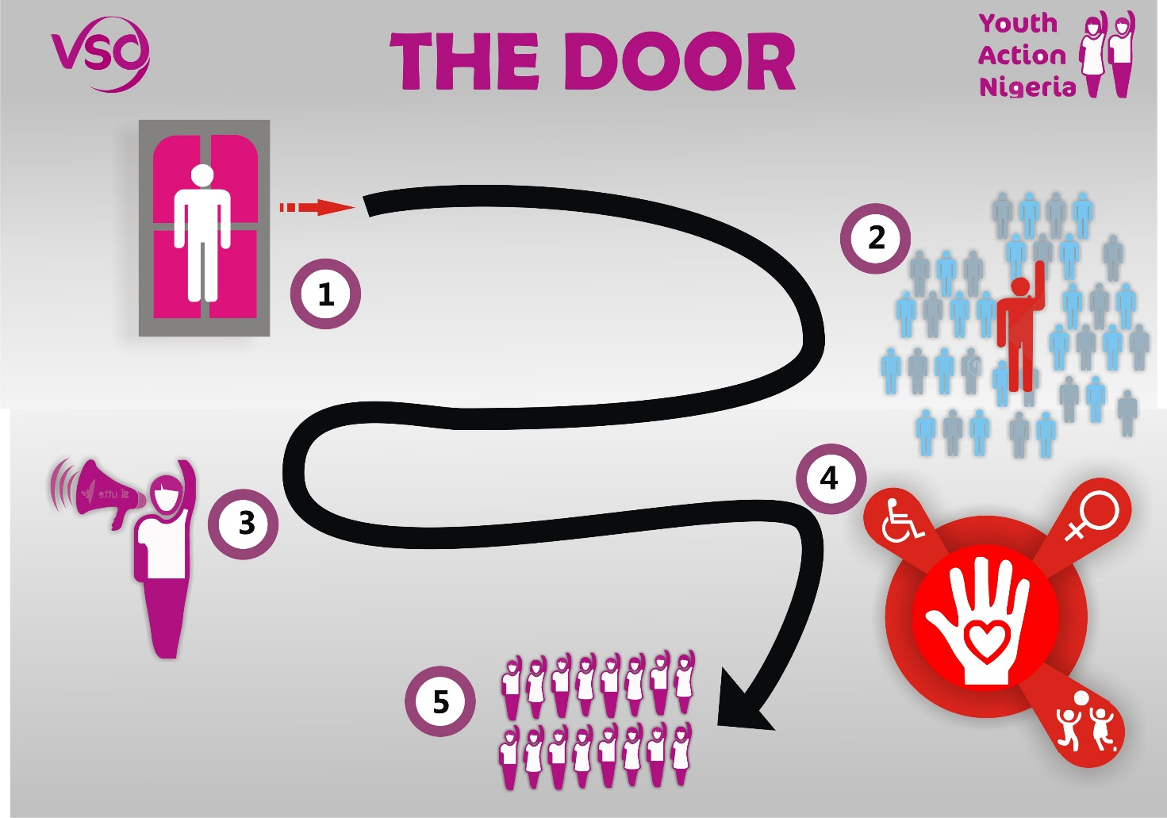

**Where are you now?**

Have you received the training? Or realised the need to be an active citizen? Your willingness to embark on this journey has earned you the place on the stage one of the journey.

***Where you are, is where you need to make a change.***

Now to proceed to stage two we encourage you to go back and make a difference in your community. Take up projects raising awareness on issues affecting your community, sensitize young people, women and children on global issues and how it affects them, bring together young people to discuss issues affecting them and participate in governance at the local level, you could team up with volunteers who you received trainings with. This has a fundraising component which will require you to raise money and resources to execute the projects you have taken up.

**Once your project has been executed you will receive a certificate of the stage two of active citizenship**.

Proceeding to stage three requires you to reach out to the beneficiaries of your project which could be young people, women or people living with disabilities around your local communities and sustain what you have started. Encourage young people to become volunteers and join the train in community citizen service. **Stage 3 certified.**

Then you proceed to Stage four; here u can volunteer on ICS, NGVP, NYSC or be CCSV’s (Community Citizen Service Volunteers) taking up community service, employing your fundraising skills to execute projects in your community. This stage is all about community citizen service (CCS). On completion of your CCS you have **stage four certified.**

The final stage will be at your presence and participation at the Returned Volunteer weekend programme, where you will share the story of your journey with other volunteer and receive **a certificate of full Active citizenship.**

Do not forget that you are part of a network of young Nigerians who are out there making change in their communities spread all over the country. **To guide and support you, contact us via email:** [**icsprogramnigeria@gmail.com**](mailto:icsprogramnigeria@gmail.com)Keep us updated on the progress you are making.

Regards